# Practical 6 Create an HTML page with 2 frames. 1st frame should contain 2 links. Clicking on which it should display related contents in the 2nd frame.

<html>

<head><title></title></head>

<frameset rows="20%,*">

<frame src="6.1.html" name="File1"/>

<frame src="6.2.3.html" name="File2"/>

</frameset>

</html>

**6.1.html**

<html>

<head><title></title></head>

<body>

<a href="C:\Users\KAUST\Desktop\IT Study Material\6S TY 1\Backup\WT\Prac4\6.html" target="File2">Click 1</a>

<a href="C:\Users\KAUST\Desktop\IT Study Material\6S TY 1\Backup\WT\Prac3\5.html" target="File2">Click 2</a>

</body>

</html>

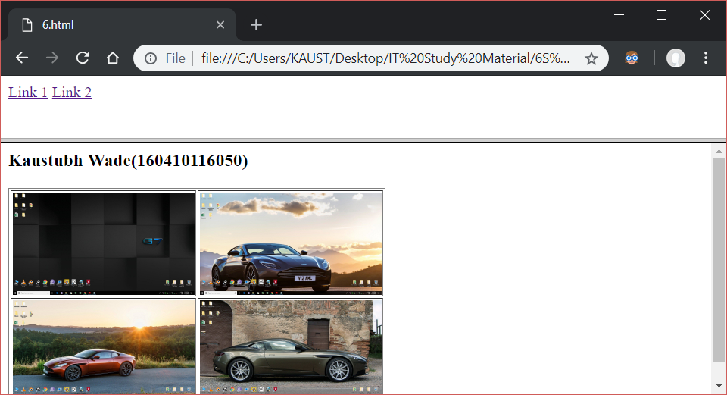

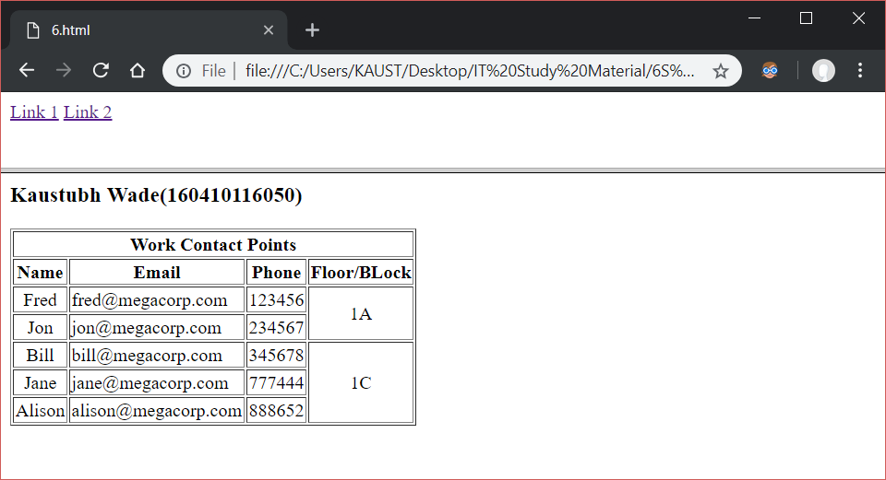

<html>

<head><title></title></head>

<frameset rows="20%,50%">

<frame src="6.2.2.html" name="box1">

<frameset cols="*,*">

<frame src="6.2.3.html" name="box2">

<frame src="6.2.4.html" name="box3">

</frameset>

</html>

**6.2.2.html**

<html>

<head><title></title></head>

<body>

<a href="C:\Users\KAUST\Desktop\IT Study Material\6S TY 1\Backup\WT\Prac4\6.html" target="box2">Link 1</a>

<a href="C:\Users\KAUST\Desktop\IT Study Material\6S TY 1\Backup\WT\Prac3\5.html" target="box2">Link 2</a>

</body>

</html>

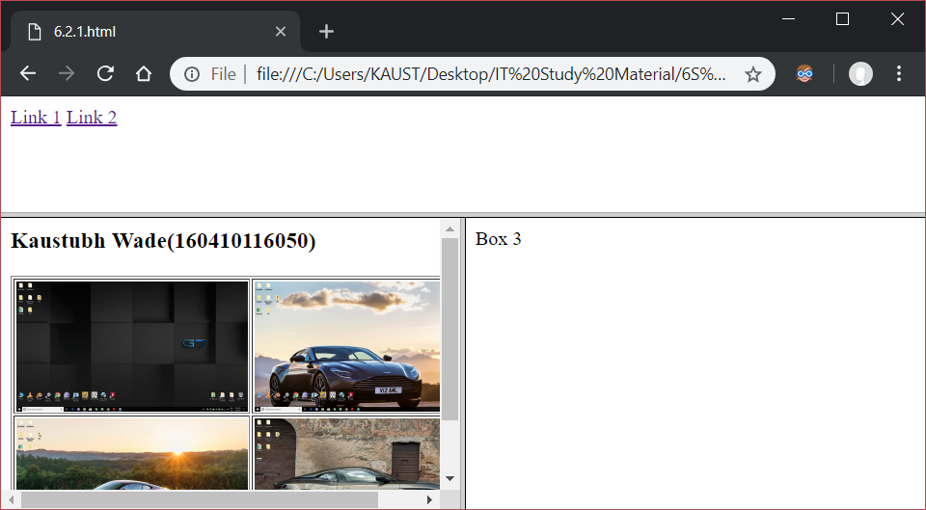

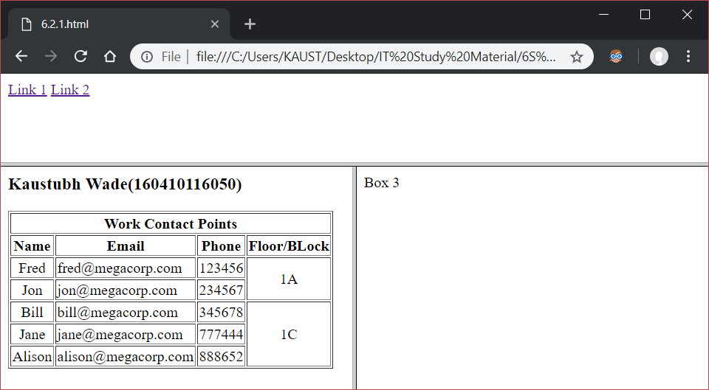

<html>

<head><title></title></head>

<frameset cols="20%,50%">

<frame src="6.2.2.html" name="box1">

<frameset rows="*,*">

<frame src="6.2.3.html" name="box2">

<frame src="6.2.4.html" name="box3">

</frameset>

</html>

